
Mākara Model School
Board of Trustees Meeting
19 February 2025 at 5.30 pm
Where | Mākara Model School and Zoom
Trustees | Ali Kirkpatrick, Genieve Morrison, James Ryan, Joe Coyle (Chair) and Rachael Kasa
Attendees | James Appleton (Principal), Andrew Graham (Deputy Principal), Denise Hutana (minutes)

1 Welcome
Ali welcomed everyone to the meeting.

Board members introduced themselves to James (Principal) who was attending the meeting for the first time.

The meeting opened with a Karakia.

2 Administration
2.1 Apologies

There were no apologies.

2.2 Declaration of Interests

The Board had no interests to declare that were relevant to the agenda.

2.3 Confirmation of Minutes 4 December 2024

The Board agreed the minutes for the meeting on 4 December 2024 were a true an accurate record and that they would be published on the school website.

2.4 Matters arising from the Minutes

There were no matters arising from the Minutes.

2.5 Actions

The Board discussed the actions (see Action table).

2.6 Decision Register

The Board made the following decisions at the meeting.
Number | Agenda Item | Decision | Moved/Seconded
1 | 4.2 | The Board APPROVED THE 2025 Budget. | Moved: Ali Kirkpatrick Seconded: Rachael Kasa
2 | 5.6 | The Board AGREED to:  Dispose of the old ride on mower.  Purchase a new ride on mower which would be managed within the current budget (and not funded through grant applications).

3. Monitoring

3.1 Principals Report

The Board thanked James A for his report and noted:

The current school roll is currently 77.

66% of students’ attendance was over 90% and 95% of attendance was over 80%.

The website includes information about the school taking Out of Zone Enrolments and states that the Board “will determine the number of places which are likely to be available in the following 6-month period…the Board will publish this information…” If the roll does not increase then the Board will discuss whether to take out of zone students.

Currently, James A is looking for some professional development on swimming instruction for staff.

The bell system is now in place, however a quote has been requested to upgrade the AMP system so it can be heard both inside and outside.

3.2 Principal Assurances

James A gave the Board the Term 1 2025 Assurances for:

School Planning and Reporting.

Learning Support.

Health Education.

Safety Management System and Worker Engagement, Participation and Representation.

Healthcare.

Digital Technology and Online Safety.

3.3 Health and Safety

The Board noted:

Registers for recording hazards, accidents and maintenance are being prepared and will be discussed at the next Board meeting.

No major accidents have occurred, however there have been some minor playground accidents.

Wasp nests have been eradicated but will continue to be checked regularly.

3.4 PCC Support for James – requirements and delegations

James is receiving support through a Beginning Principal mentor and a Community of Practice. He is comfortable that he has enough support and coaching at this time. He will come back to the Board should the situation change.

4 Finances

4.1 Finance Report

The Board thanked James A for the Financial Management Report for 31 December 2024.

4.2 Draft Budget for 2025

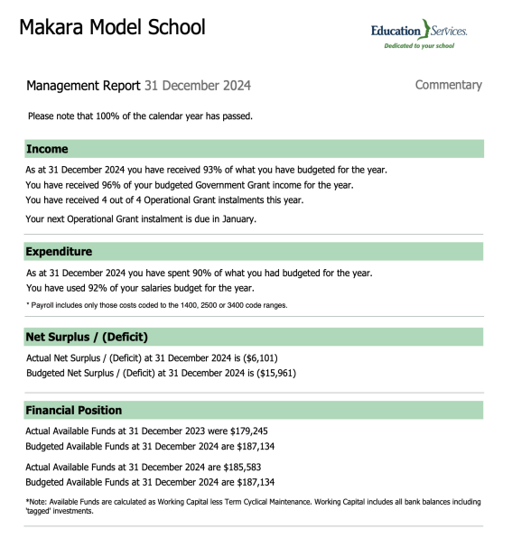

The Board noted that the draft 2025 budget presented differs from that presented at the December 2024 meeting as:

Income has reduced as $6000 was inadvertently included as income under Principal Wellbeing. This funding was under the Principal’s collective for 2023 and 2024 only and the unspent funding in 2024 of $2,800 has been carried forward to 2025.

The estimated available funds as at December 2024 to carry forward was $185,000 and the estimated available cash as at December 2025 was $175,000.

Mubina considers that the school is in a good financial position as the cash reserves are close to 100% of our Operational Grant from the Ministry.

Action: James A to invite Mubina Merchant (Education Services) to the next Board meeting to discuss the 2025 budget.

Decision: The Board APPROVED THE 2025 Budget.

Moved: Ali Kirkpatrick Seconded: Rachael Kasa

4.3 Grants and Fundraising

The Board noted the two grant applications currently being prepared:

Nikau for up to $2000 for new sports equipment.

Meridian which may be used for projects (eg football goals for the top field).

The Board thanked Jenny for her efforts in completing the grant applications.

5 Strategic Decisions

5.1 Board of Trustees Elections

The Board noted:

Once the date for the Board election is confirmed the Chair will complete the forms required to appoint a returning officer (Ministry of Education funded).

Each School Board of Trustees is required to have between 3 and 7 members. Ideally it would be good to have more than 7 nominations so that a vote is required.

5.2 Code of Conduct

The Board noted:

The Code of Conduct was last reviewed in 2022.

The content still appears relevant and only minor changes are required (eg grammar and updated dates). Once finalised it will be loaded onto school docs.

Action: James A to remind staff about the requirement to regularly update their passwords.

Action: Ali to ask Gwyneth if she has the original code of conduct document.

Action: James R to provide Board members with instructions on two factor verification to access Board shared documents.

5.3 Government Guidelines

The Board noted that the Government Guidelines have been reviewed and will be loaded to School docs.

Schedule of Delegations

The Board noted that currently the Principal has delegated spending approval up to $1,000 and the Board is required to approve all expenditure over $1,000.

Action: Ali to make final changes to the Schedule of Delegations.

Conflicts of Interest Policy

The Board noted:

A template is available on the NZSTA website to use for determining conflicts of interest.

The school does not currently have a Conflicts of Interest policy for either staff or trustees.

Action: Genieve to draft a Conflict of Interest Policy to be discussed at the next Board meeting.

5.6 New ride on mower and disposal of old one

The Board noted:

The deck that holds the blades on the ride on mower needs replacing at an estimated cost of $1,000.

The mower is old and it will be costly to maintain going forward.

A new ride on mower could be purchased for approximately $9,000.

Grants could be applied for to cover the cost, however, there is an immediate need to replace the mower and the application process can be lengthy with unknown outcomes.

Two quotes have been received with one including servicing at the school which is considered an advantage.

Decision: The Board AGREED:

To dispose of the old ride on mower.

To purchase a new ride on mower which would be managed within the current budget (and not funded through grant applications).

Standing Items

6.1 Term One Policy Review

The Board noted that the 2025 policy review schedule is available and in Term One the following policies will be reviewed:

Health, Safety, and Welfare Policy.

Safety Management System.

Risk Management.

Healthcare.

Worker Engagement, Participation and Representation.

Recording and Reporting Accidents, Injuries and Illness.

6.2 Complaints Register

No complaints have been received since the last Board meeting.

Other Business

Board Work Programme

The Board noted:

The NZSTA have recommended that the Board has an annual workplan.

The plan would enable the scheduling of activities to be discussed at Board meetings throughout the year.

Action: James A and Joe to develop a draft work plan (including policy reviews) for discussion at the next Board meeting.

Identify Agenda Items for the next meeting

The Board noted the following items would be discussed at the next meeting:

Registers for recording hazards, accidents and maintenance.

Conflict of Interest Policy.

Draft work plan.

8. In-committee items

The Board had no in-committee items to discuss.

8. Meeting closed

The Chair thanked everyone for attending and closed the meeting with a Karakia.

The meeting closed at 7.00 pm.
Chair | Date

